Table of Contents

Abstract 2

References 3

Architecture 4

Palagarism Scan Report 5

Summary 7

SCI/Scoupus Indexed Journals 8

# Abstract

This research focuses on designing and implementing a scalable, intelligent, and domain-agnostic recommendation system as part of the Customer360 platform. The goal is to enhance digital user experiences by delivering personalized suggestions across various industries, such as e-commerce, e-learning, and media streaming. Unlike traditional systems that are confined to specific domains, this cross-domain recommender is designed to work with minimal input, allowing businesses to generate meaningful item recommendations using limited customer data.

A major challenge in recommendation systems is dealing with data sparsity and the cold-start problem—situations where little or no historical user-item interaction data is available. This research addresses these limitations through a hybrid deep learning approach that combines semantic feature extraction with collaborative filtering. Techniques like BERT are used to extract meaning from unstructured textual data, while methods such as Neural Collaborative Filtering (NCF) and matrix factorization help model user preferences and item similarities. This hybrid architecture enables the system to perform well even with sparse data, providing personalized and context-aware recommendations.

As digital platforms grow more complex and user expectations for personalization increase, conventional recommendation methods often fall short in real-time responsiveness and adaptability. This system is built to scale and operate efficiently in heterogeneous data environments, supporting real-time use cases where traditional models struggle. By leveraging structured and unstructured data sources, the system can make more informed predictions, resulting in higher accuracy and better user satisfaction.

The end product of this research will be a RESTful Web API that integrates seamlessly with business platforms. This API enables companies across different sectors to request and receive recommendations using only basic customer information. Performance evaluation of the system will be conducted using widely accepted metrics, including Root Mean Square Error (RMSE), Mean Reciprocal Rank (MRR), and Precision. The system’s ability to generalize across domains and deliver explainable recommendations makes it a versatile solution for many real-world applications.

Customer360 provides a comprehensive ecosystem to support this recommender system. It integrates data from multiple sources, applies transfer learning techniques, and gathers user-specific input through a mobile application that serves as a personal assistant. The recommendation engine is central to this ecosystem, enabling businesses to access high-quality, personalized suggestions through the Web API. This research represents a step forward in the development of adaptable, intelligent recommendation systems that can serve diverse business needs with minimal overhead.

# References

[1] Adem Tekerek Rand Jawad, Kadhim Almahmood. *Issues and solutions in deep*

*learning-enabled recommendation systems within the e-commerce field.* Applied Science,

12, 2022.

[2] Hamidah Ibrahim Maslina Zolkepli Fatimah Sidi Caili Li Caiwen Li, Iskandar Ishak.

*Deep learning-based recommendation system: Systematic review and classification.*

IEEE, 2023.

[3] Fan Lin Lixin Zou Pengcheng Wu Wenhua Zeng Huanhuan Chen Chunyan Miao

Yuanguo Lin, Yong Liu. *A survey on reinforcement learning for recommender systems.*

IEEE, 2024.

[4] Nacim Yanes, Ayman Mohamed Mostafa, Mohamed Ezz, and Saleh Naif Almuayqil.

*A machine learning-based recommender system for improving students learning experiences.*

IEEE Access, 8:201218–201235, 2020.

[5] John Kingsley Isaac Tawiah Benjamin Doh Ronky Francis, Conghua Zhou. *A systematic*

*review of deep knowledge graph-based recommender systems, with focus on*

*explainable embeddings.* mdpi.

[6] Ruihui Mu. *A survey of recommender systems based on deep learning.* IEEE Access,

6:69009–69022, 2018.

[7] Yaochu Jin Qian Zhang, Jie Lu. *Artificial intelligence in recommender systems.*

Springer, 2021.

[8] Shuai Zhang, Lina Yao, Aixin Sun, and Yi Tay. *Deep learning based recommender*

*system: A survey and new perspectives.* ACM Computing Surveys (CSUR),

52(1):5:1–5:38, 2019.

[9] Keqian Li Laks V.S. Lakshmanan Wei Lu, Shanshan Chen. Show me the money:

*Dynamic recommendations for revenue maximization.* arxiv.

[10] Safiullah Kamawal Armin Toroghi Ananya Raval Farshad Navah Amirmohammad

Kazemeini Shaina Raza, Mizanur Rahman. *A comprehensive review of recommender*

*systems: Transitioning from theory to practice.* arxiv.

# Architecture

Deep learning-based recommender systems have shown promising results, offering improved

accuracy over traditional approaches. However, they still face challenges such

as data sparsity and the cold-start problem. One effective way to address these issues

is through cross-domain recommendation, where insights gained in one domain can be

transferred to another for similar users.

The Customer360 platform tackles this challenge using a slightly different strategy.

It integrates data from multiple sources, applies transfer learning, and also gathers user

data directly. As a comprehensive solution, Customer360 includes:

* A mobile application that acts as a personal assistant to users,
* A recommendation system powered by multi-source data, including user-specific
* input,
* A Web API that allows businesses to access personalized recommendations.

In this project, the focus will be solely on developing the recommendation system, which

will be made available through a Web API. Businesses across various domains can use

this API by providing minimal customer information and, in return, receive a list of

recommended items tailored to their users

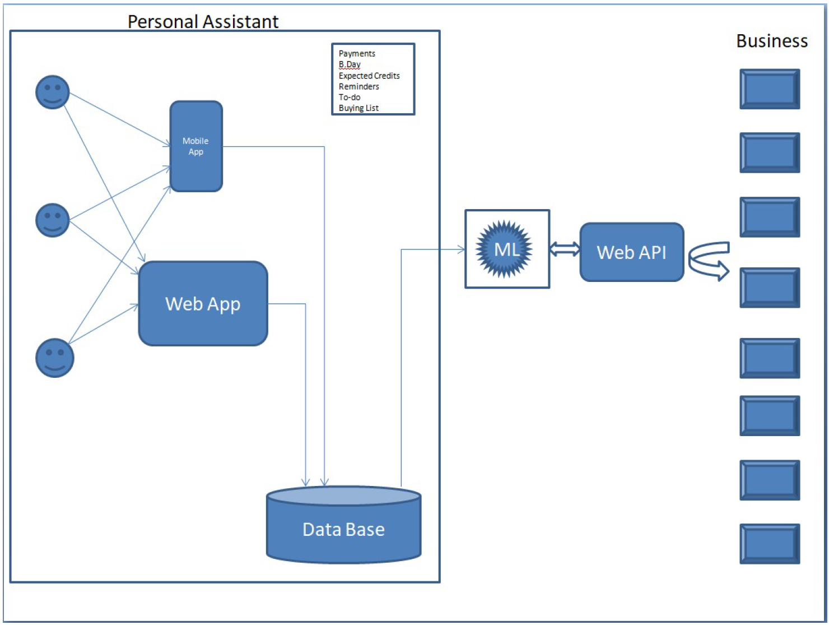

# Palagarism Scan Report

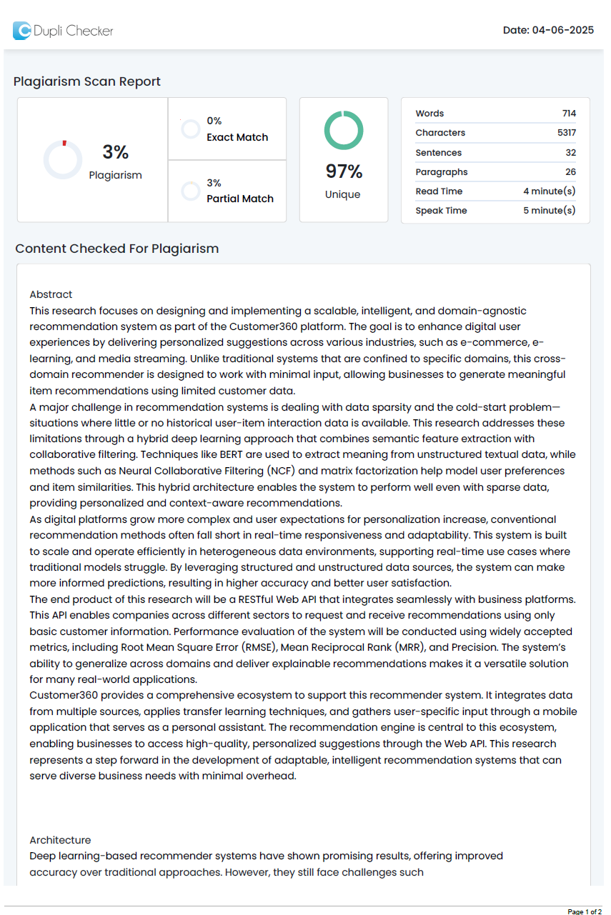

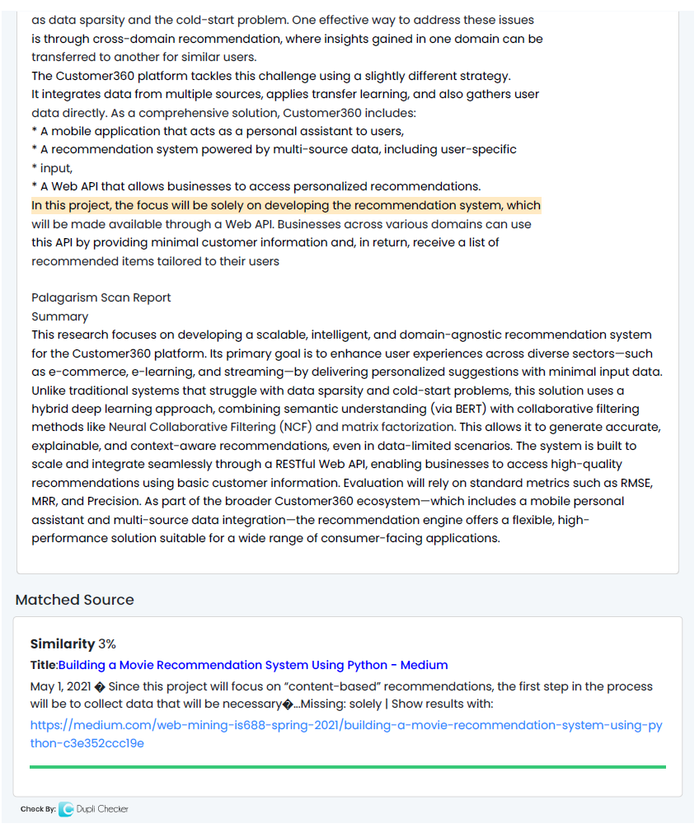

# Summary

This research focuses on developing a scalable, intelligent, and domain-agnostic recommendation system for the Customer360 platform. Its primary goal is to enhance user experiences across diverse sectors—such as e-commerce, e-learning, and streaming—by delivering personalized suggestions with minimal input data. Unlike traditional systems that struggle with data sparsity and cold-start problems, this solution uses a hybrid deep learning approach, combining semantic understanding (via BERT) with collaborative filtering methods like Neural Collaborative Filtering (NCF) and matrix factorization. This allows it to generate accurate, explainable, and context-aware recommendations, even in data-limited scenarios. The system is built to scale and integrate seamlessly through a RESTful Web API, enabling businesses to access high-quality recommendations using basic customer information. Evaluation will rely on standard metrics such as RMSE, MRR, and Precision. As part of the broader Customer360 ecosystem—which includes a mobile personal assistant and multi-source data integration—the recommendation engine offers a flexible, high-performance solution suitable for a wide range of consumer-facing applications.

# SCI/Scoupus Indexed Journals

1. **ACM Transactions on Information Systems (TOIS)** *Publisher:* ACM *Scope:* Covers recommendation systems, information retrieval, and user modelling. *Indexing:* SCI, Scopus https://dl.acm.org/journal/tois

2. **IEEE Transactions on Knowledge and Data Engineering (TKDE)** *Publisher:* IEEE *Scope:* Data mining, machine learning, recommender systems. *Indexing:* SCI, Scopus https://ieeexplore.ieee.org/xpl/RecentIssue.jsp?punumber=69

3. **Information Sciences** *Publisher:* Elsevier *Scope:* Intelligent systems, recommender algorithms, deep learning. *Indexing:* SCI, Scopus https://www.journals.elsevier.com/information-sciences

4. **Expert Systems with Applications** *Publisher:* Elsevier *Scope:* AI-driven systems, hybrid recommender models. *Indexing:* SCI, Scopus https://www.journals.elsevier.com/expert-systems-with-applications

5. **Pattern Recognition Letters** *Publisher:* Elsevier *Scope:* Pattern analysis, neural networks, recommender systems. *Indexing:* SCI, Scopus https://www.journals.elsevier.com/pattern-recognition-letters

6. **Journal of Intelligent Information Systems** *Publisher:* Springer *Scope:* Decision support, intelligent agents, recommendation techniques. *Indexing:* SCI, Scopus https://www.springer.com/journal/10844

7. **Knowledge-Based Systems** *Publisher:* Elsevier *Scope:* Hybrid intelligence systems, deep learning models. *Indexing:* SCI, Scopus https://www.journals.elsevier.com/knowledge-based-systems

8. **Big Data Research** *Publisher:* Elsevier *Scope:* Big data analytics, real-time recommendation. *Indexing:* Scopus https://www.journals.elsevier.com/big-data-research

9. **Applied Intelligence** *Publisher:* Springer *Scope:* Intelligent systems, recommendation frameworks.